MedAssitAI: Medical Symptom Analysis &

Disease Prediction System

Submitted By
Name: Diksha
Team: 2
Role: Fronted

Project Overview
During this milestone, I worked on understanding and testing the Authentication and Authorization module received from my teammate. Since my role is frontend development, my objective was to verify whether the backend authentication module was ready for frontend integration. I configured the backend locally, ran the FastAPI server, and examined the available authentication endpoints through Swagger UI. While testing, I identified issues in the backend database that currently prevent successful integration.

Work Completed

1. Backend Setup
I configured the Authentication and Authorization backend provided by my teammate and successfully executed the FastAPI server using Uvicorn.
Tasks performed
- Configured the backend project.
- Started the FastAPI server.
- Verified that the server was running successfully.
- Accessed the Swagger documentation.
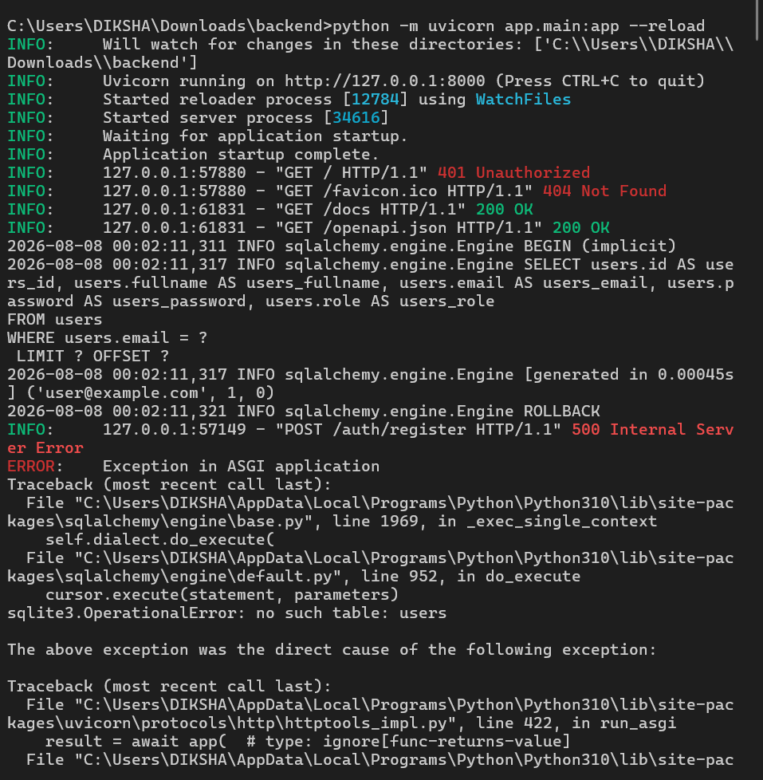

2. Swagger Documentation Review
After running the backend, I explored the Swagger UI to understand the authentication flow.
The available endpoints included:
- Register
- Login
- Patient Dashboard
- Doctor Dashboard
- Admin Dashboard
This helped me understand the request structure that the frontend will eventually use during integration.

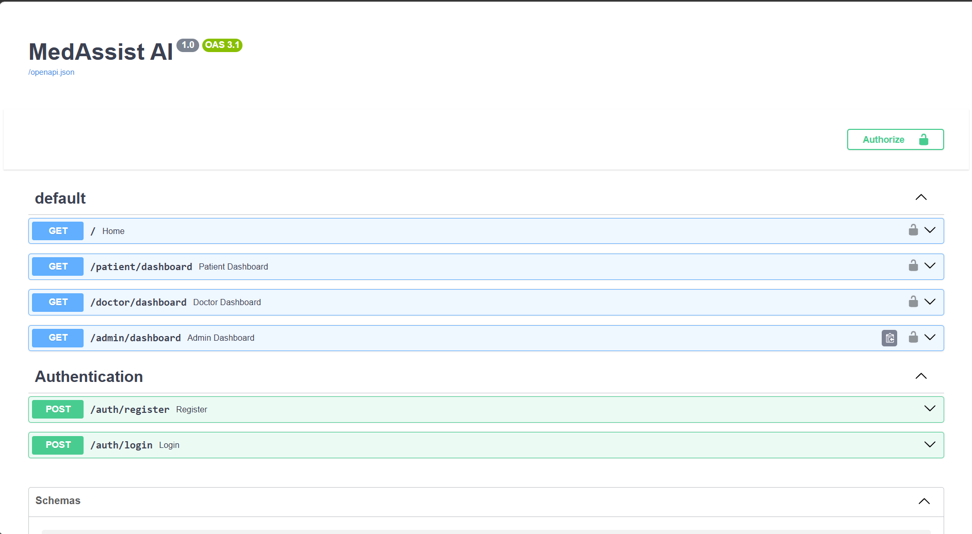
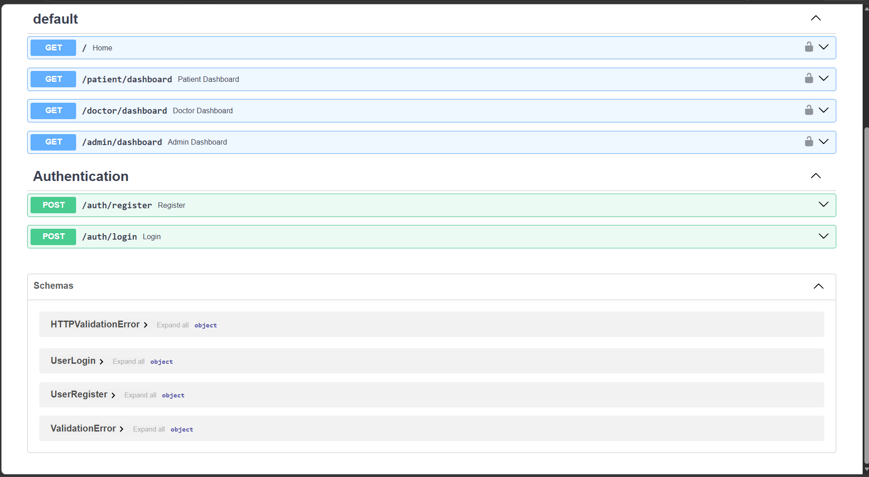

3. Authentication Module Testing
I attempted to test the Register and Login endpoints using the sample request bodies provided in Swagger.
During testing, both endpoints returned an Internal Server Error because the backend database had not been initialized.
The following issue was identified:
sqlite3.OperationalError: no such table: users
This indicates that the authentication logic exists but the database initialization has not yet been completed
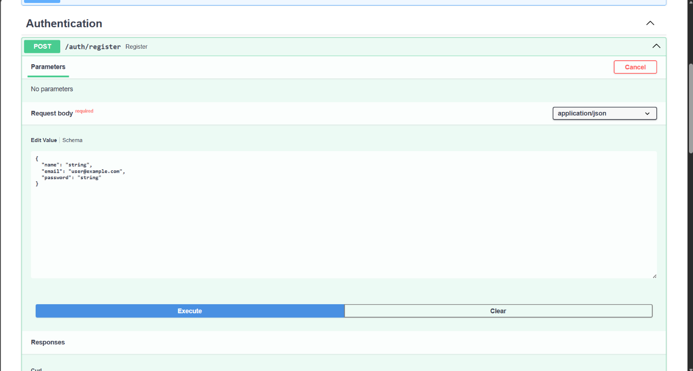
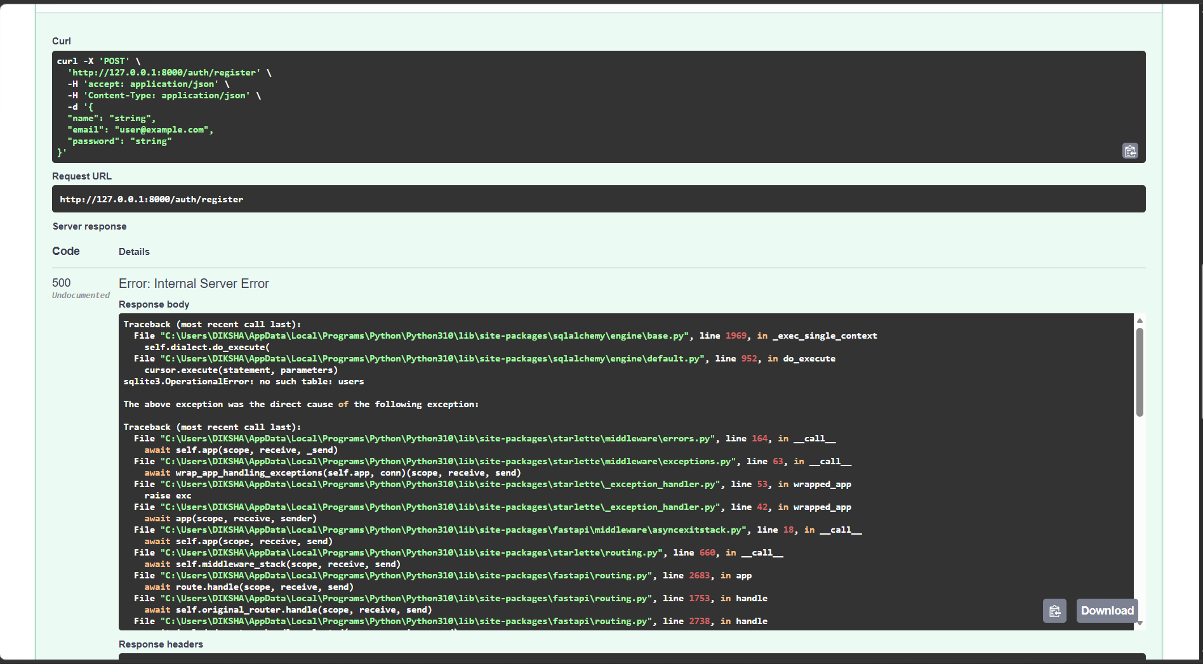
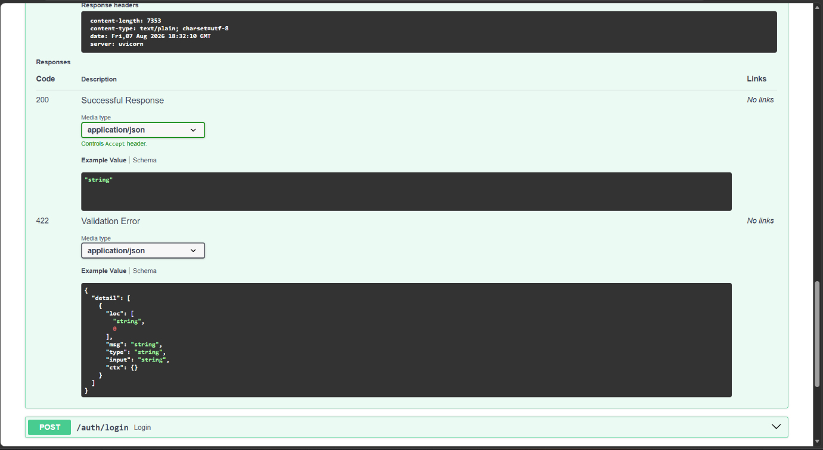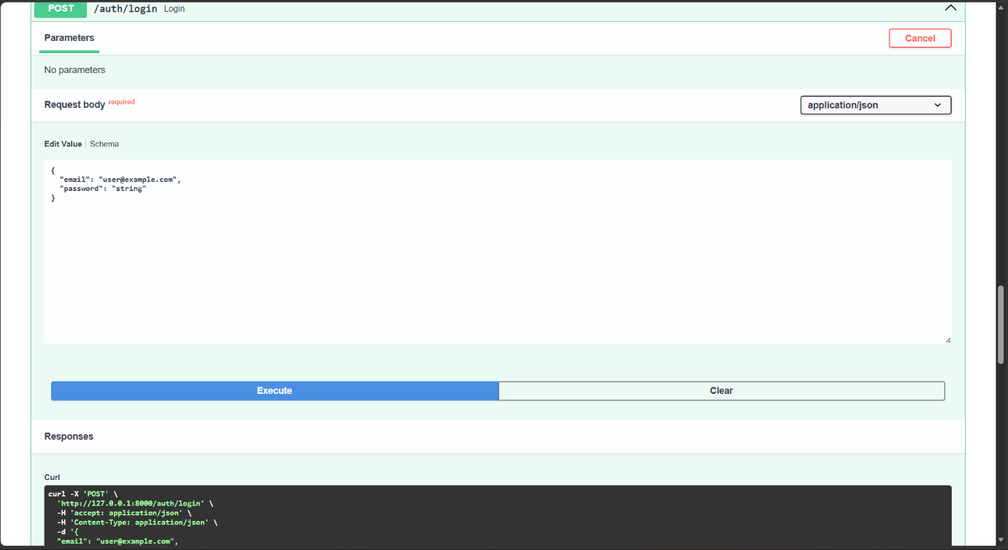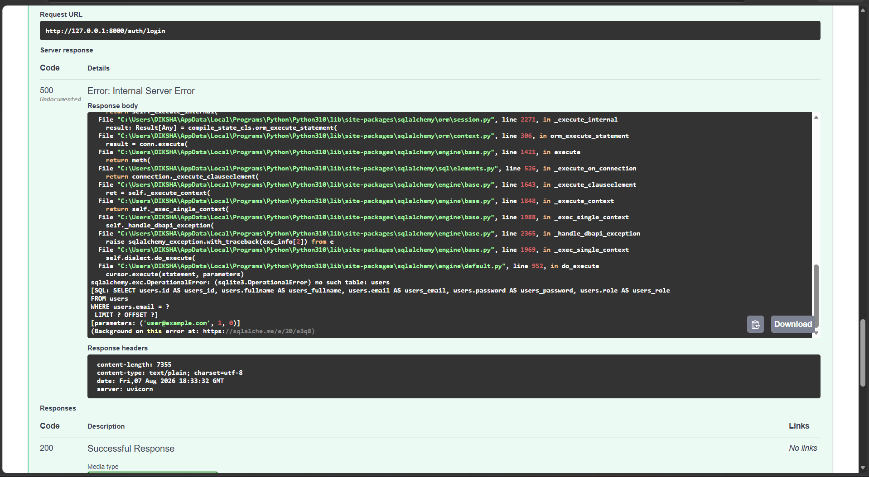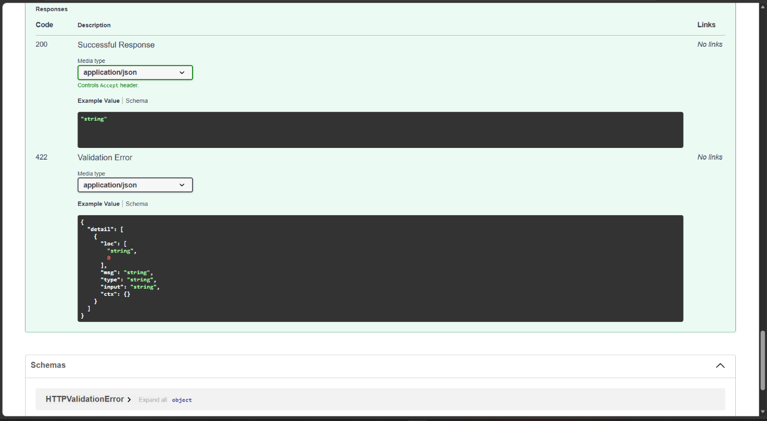

4. Analysis
Based on testing, I concluded that the backend authentication module still requires database configuration before it can be integrated with the frontend.
Therefore, frontend-backend integration was postponed until the backend implementation is completed.

Learning Outcome
During this milestone, I learned:
- How to configure and execute a FastAPI backend.
- How to use Swagger UI to inspect backend APIs.
- How Authentication and Authorization endpoints are structured.
- How to identify backend issues through server responses and error logs.
- The importance of verifying backend readiness before frontend integration.

Conclusion
During this milestone, I successfully verified and tested the Authentication and Authorization backend module provided by my teammate. The backend server and API documentation were successfully executed and examined. While testing, a database configuration issue was identified, preventing successful authentication. The issue was documented, and the frontend integration will proceed after the backend database is fully configured.

